=== Cluster Architecture

2025年4月16日

下午 01:25

ETCD

2025年4月16日

下午 01:26

Kuber-apiserver

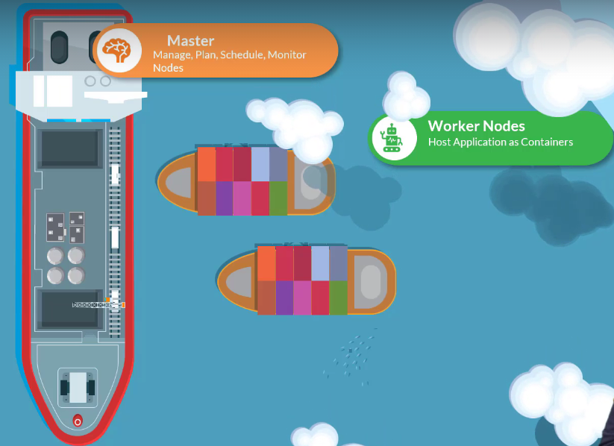

ETCD Cluster (database):

Stores key-value pair data

Kube-scheduler (Crane)

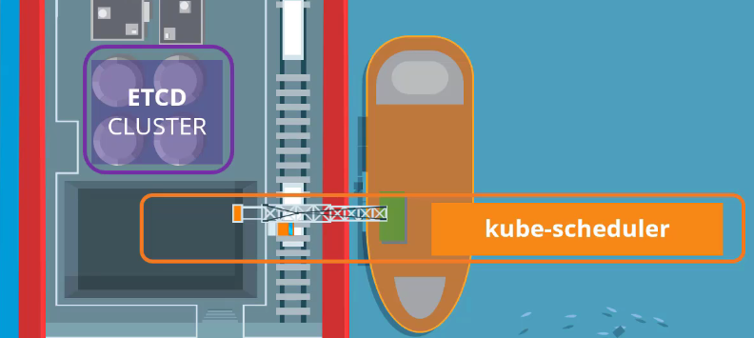

Controller-Manager

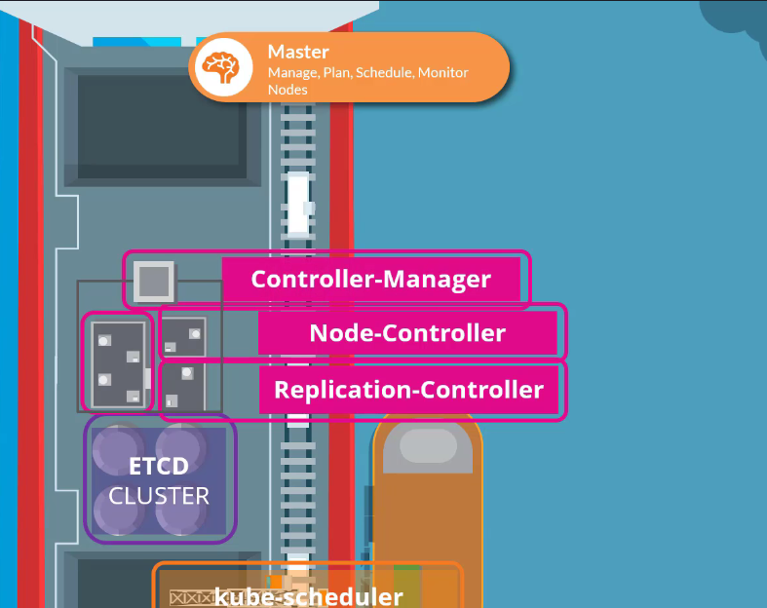

Kubelet (agent) on each Ship with Docker containers:  
- Listens for instruction from kube-apiserver

- Deploy / destroy containers on the nodes

kuber-api server regularly fetches status report from kubelet

to monitor status of nodes

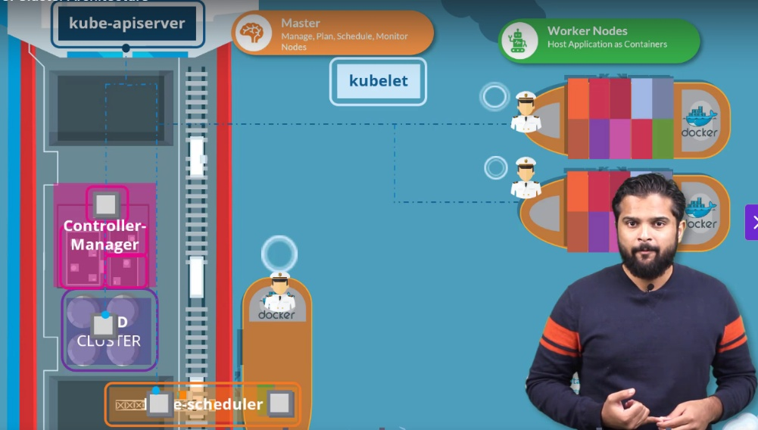

kube-proxy allows cross worker nodes communication

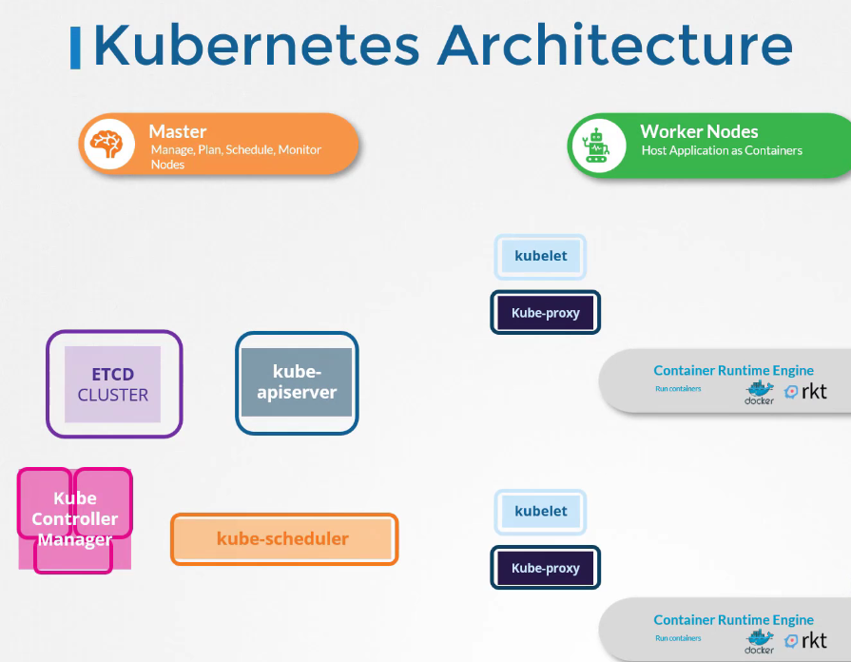

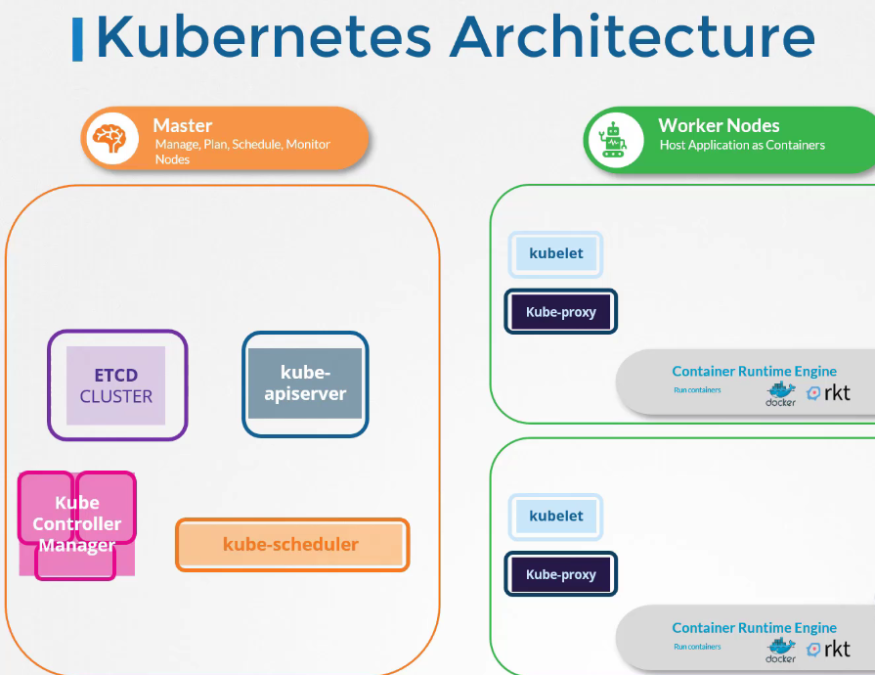

Docker vs container-d

2025年4月16日

下午 01:40

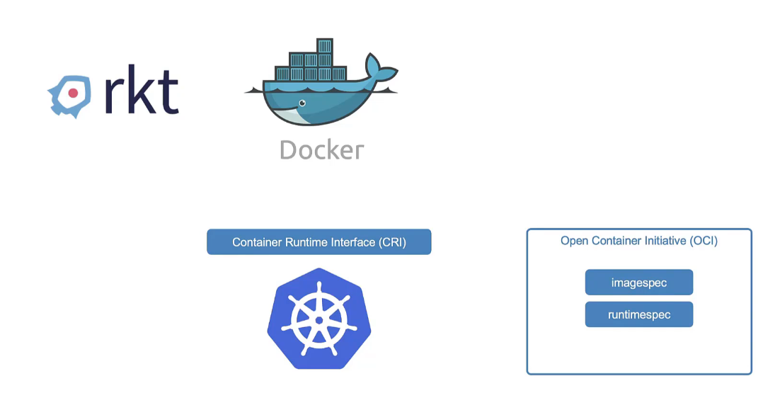

Docker comes before rkt (rocket)

rkt uses Container Runtime Interface (CRI) to work with Kubernetes

While, Kubernetes works with Docker using dockershim

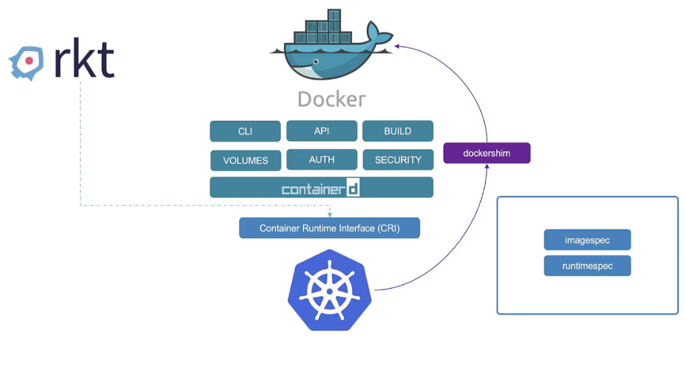

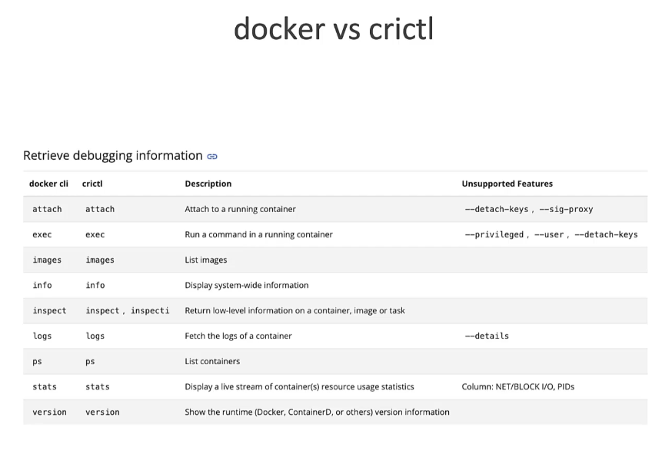

ETCD for beginners

2025年4月16日

下午 01:55

* What is ETCD?
* What is key-value store
* How to get started quickly?
* How to operate ETCD?

Later:

* What is a distributed system?
* How ETCD operates
* RAFT protocol
* Best practices on number of nodes

ETCD:

A distributed reliable key-value store, simple, secure & fast

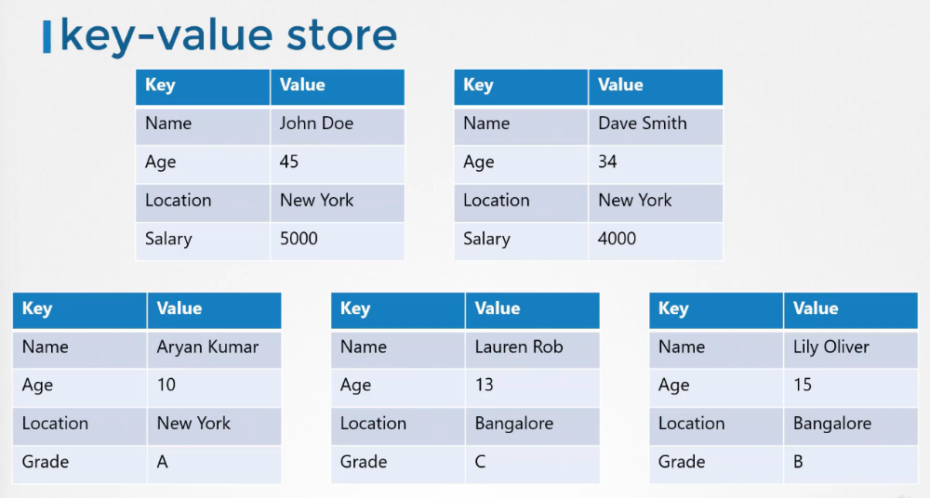

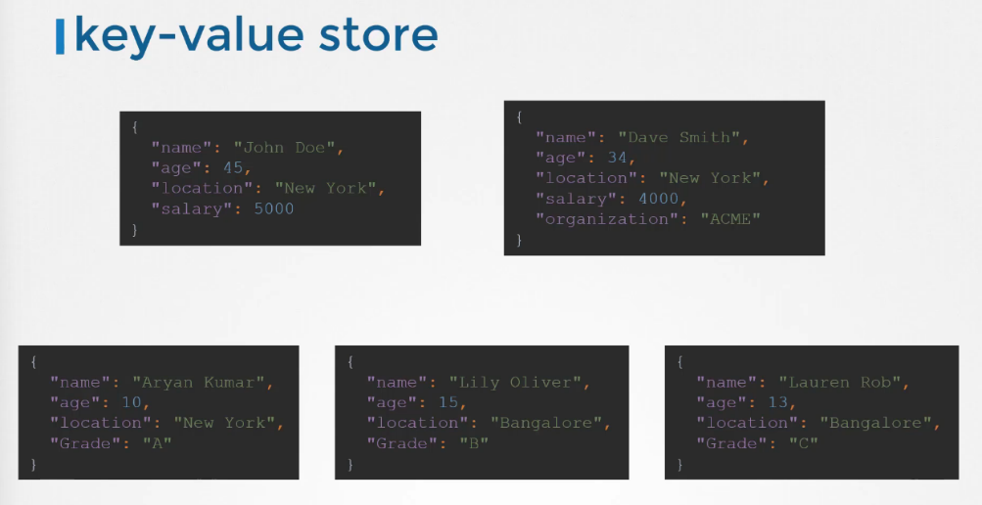

Install ETCD

2025年4月16日

下午 02:02

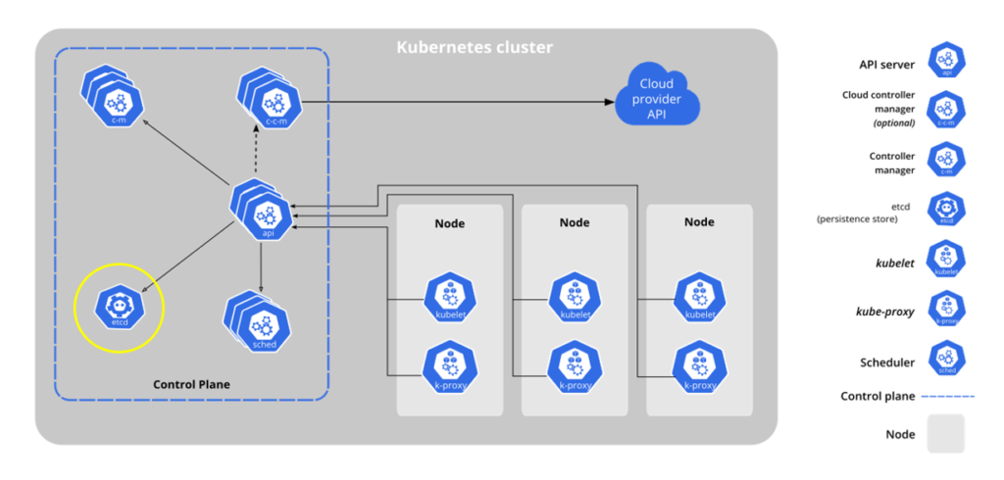

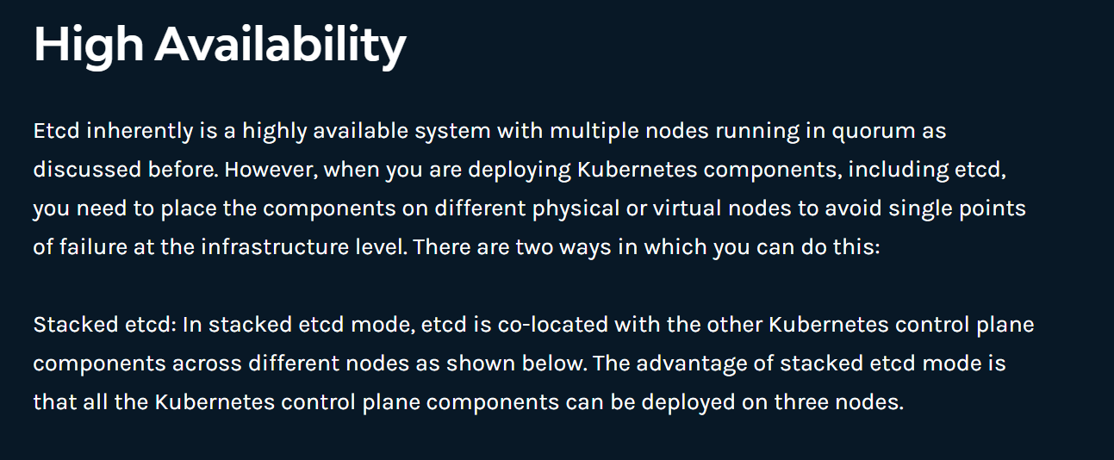

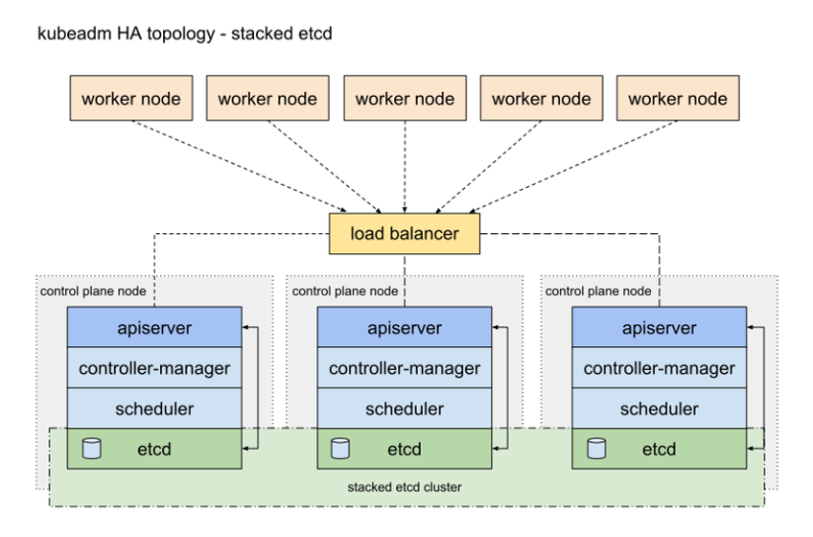

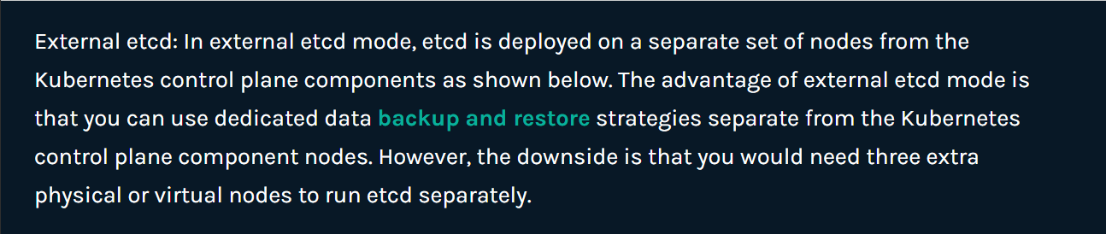

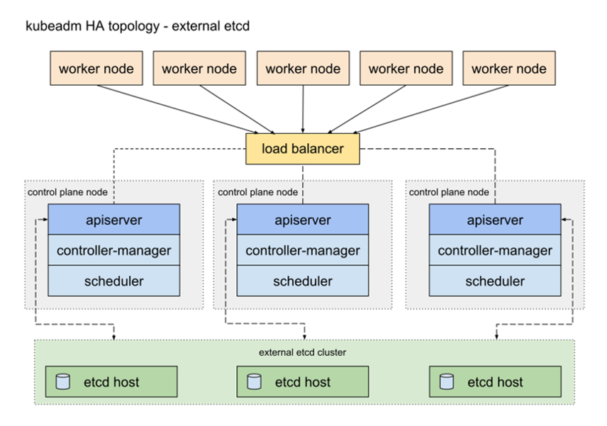

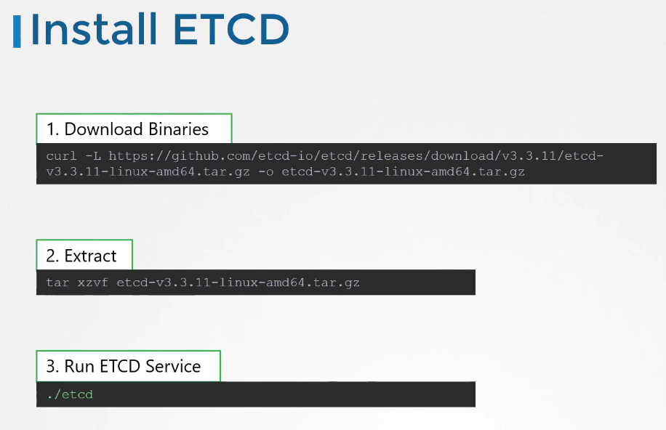

ETCD listens on TCP port 2379 by default

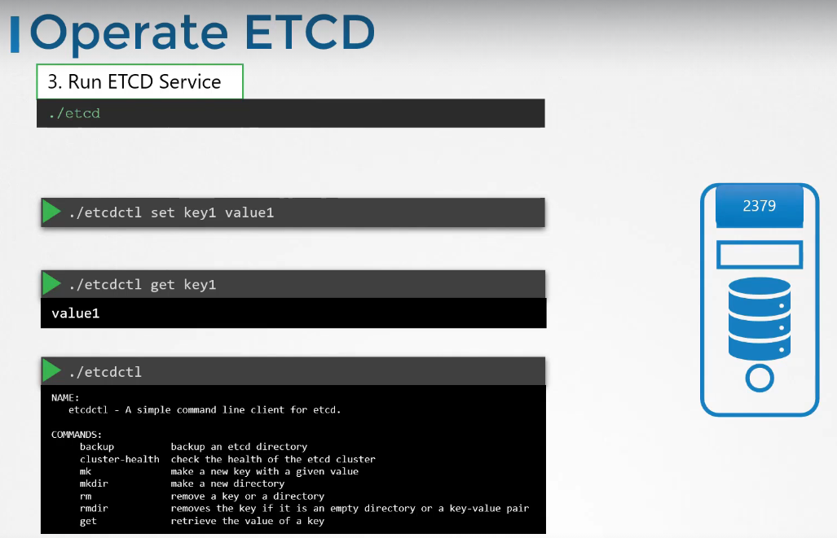

./etcdctl retrieves key-value pairs

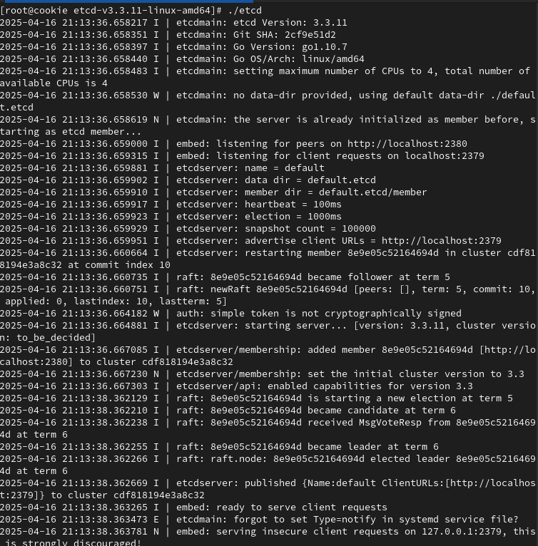

etcdctl

2025年4月16日

下午 09:15

Storing a key-value pair into etcd manually

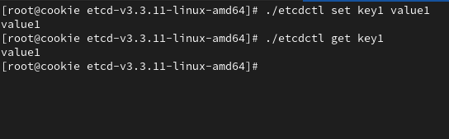

ETCD Cluster

2025年4月16日

下午 09:20

1

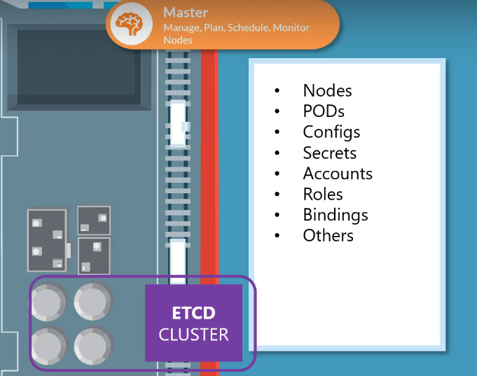

Setting up ETCD Cluster manually from scratch

wget -q --https-only \

"<https://github.com/coreos/etcd/releases/download/v3.3.9/etcd-v3.3.9-linux-amd64.tar.gz>"

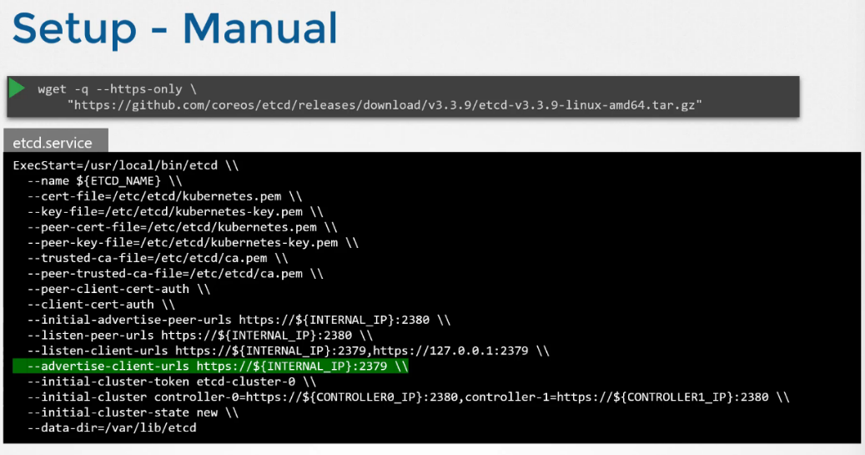

kubectl get pods -n kube-system

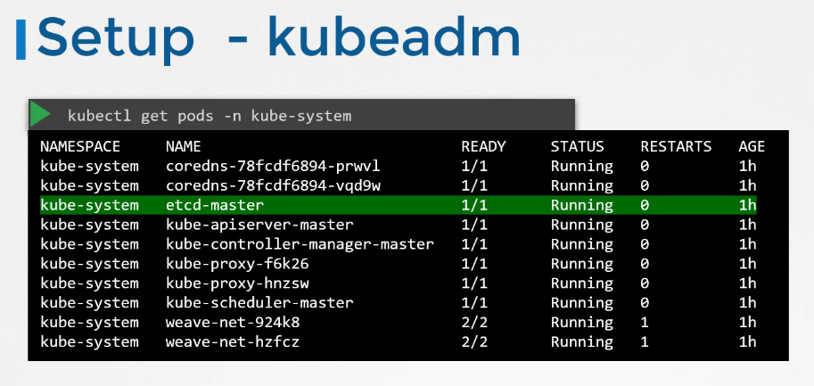

=== EKS

2025年4月19日

下午 02:13

K8S architecture

2025年4月19日

下午 02:14

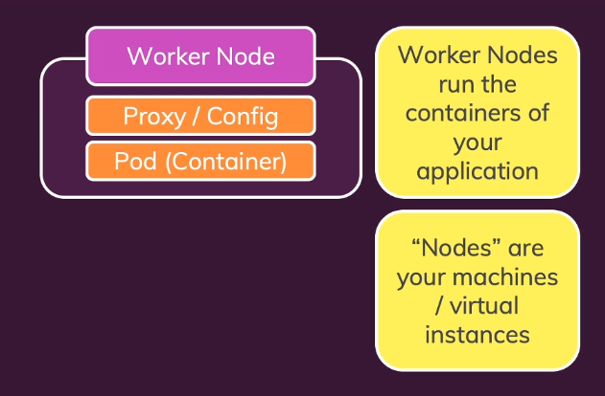

At least 1 worker node -> 1 pod (container)

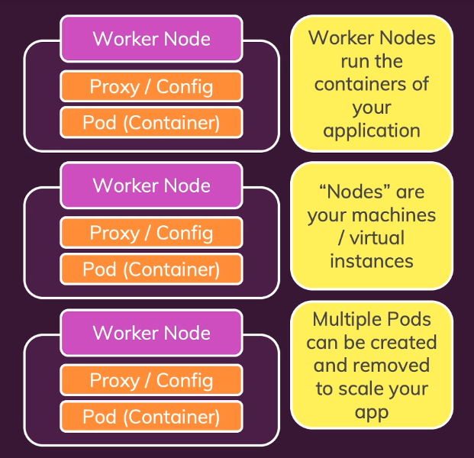

Control Plane

2025年4月19日

下午 02:15

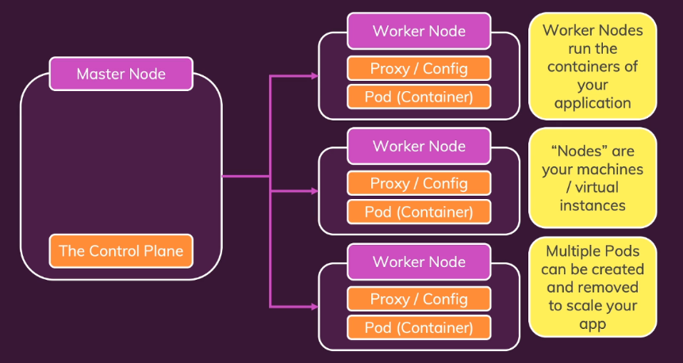

Master Node (Control Plane) = Doing all heavy lifting for controlling Pods

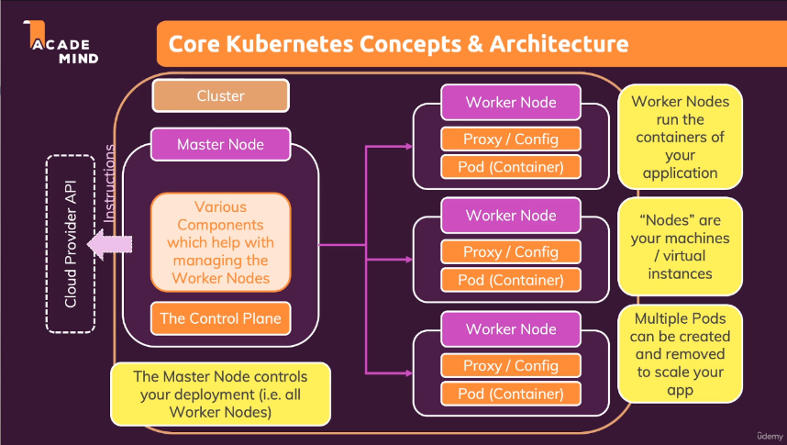

K8S doesn't setup Cluster

2025年4月19日

下午 02:20

You have to create & setup Cluster &

Node Instances (Worker + Master Nodes)

Setup API Server, kubelet & other K8S services / software on Nodes

Create other (cloud) provider resources (Load Balancer, Filesystems)

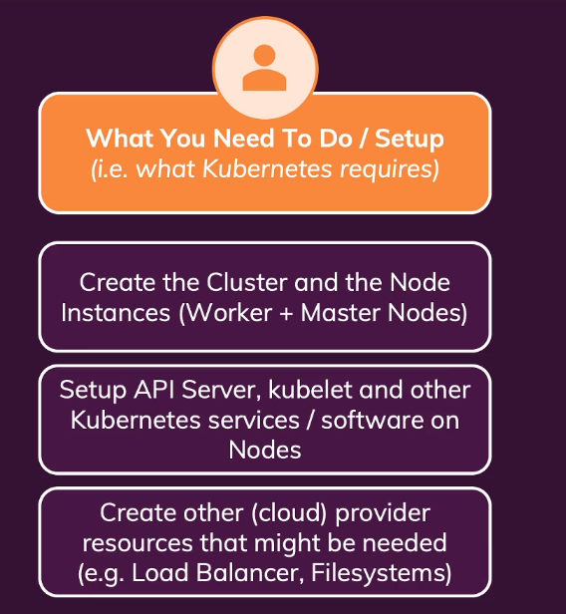

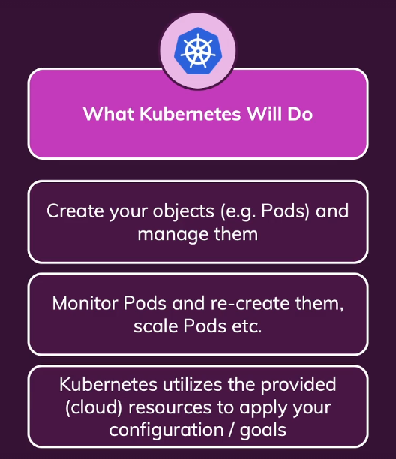

Worker Nodes

2025年4月19日

下午 02:23

Worker Node = ECS2

Pod = Volumes + Containers

+1 Pod in Worker Node

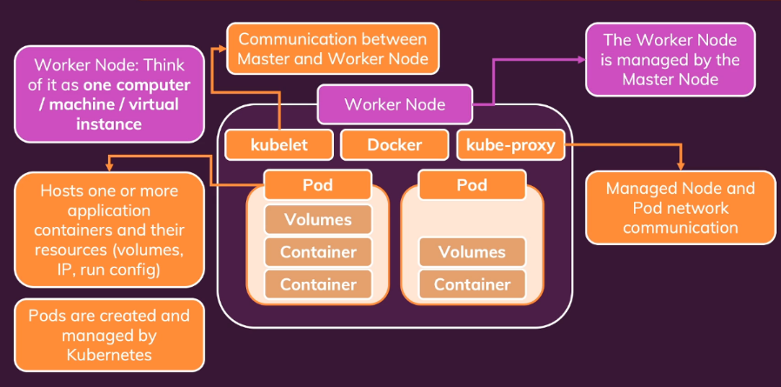

kubelete service:

Counterpart for Master Node API Server

Worker Node <-> Master Node communication

Container runtime (Docker)

kube-proxy service

Master Node

2025年4月19日

下午 02:29

API Server:

Counter point for Kubelets

[Master <-> Worker communications]

Scheduler:

- Watching Pods

- Choosing Worker Nodes for new Pods to be created on

- During Scaling -> create a new Pod

Kube-Controller-Manager:

- Watches & controls Worker Nodes

- Ensuring correct number of Pods

Cloud-Controller-Manager:

- Knows how to interact with Cloud Provider resources

- Translate instructions to AWS/Azure Cloud Provider API

Core components

2025年4月19日

下午 02:35

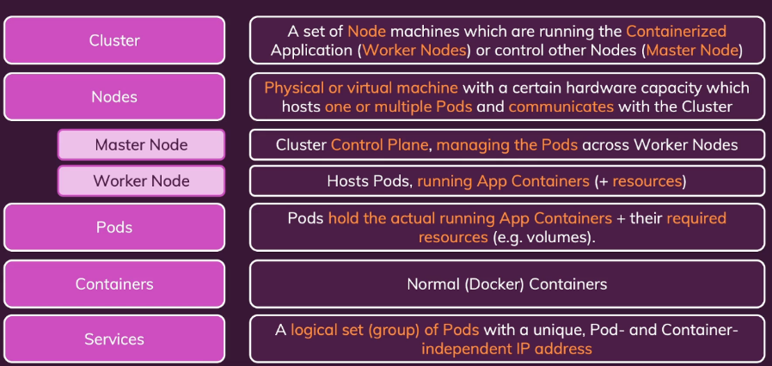

K8S Cluster = A network of machines which are split up in Worker & Master Nodes

Pod = Shell + config + volumes for Containers to run inside

===

2025年4月19日

下午 02:53

Installation

2025年4月19日

下午 02:59

Cluster

Master Node

+1 Worker Nodes

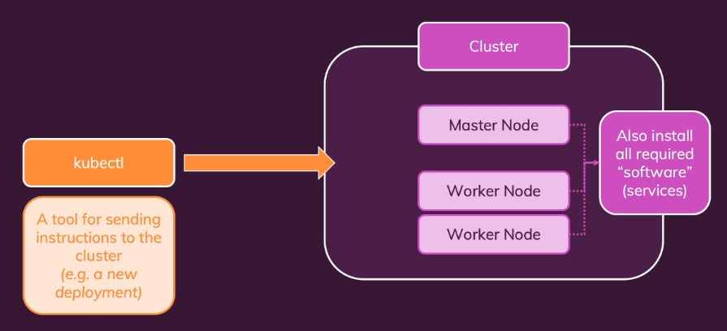

Windows Minikube

2025年4月19日

下午 03:04

Installing kubectl

powershell -> systeminfo

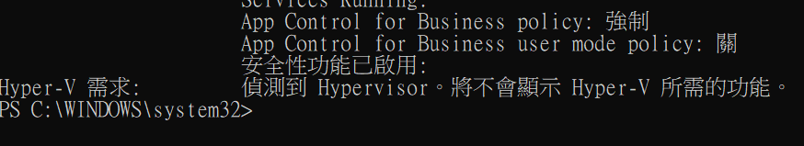

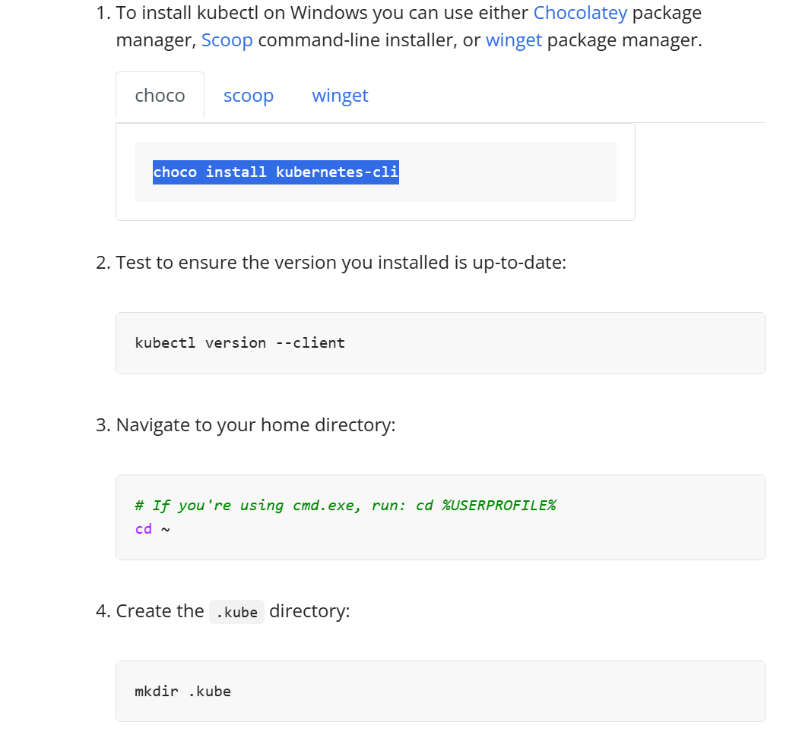

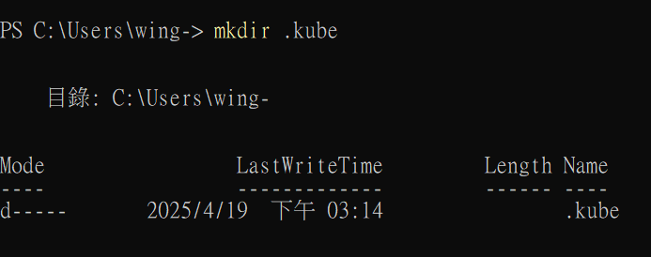

Installing minikube

<https://minikube.sigs.k8s.io/docs/start/?arch=%2Fwindows%2Fx86-64%2Fstable%2F.exe+download>

**Starting up minikube using virtualbox driver**

**(Master Node + Worker Node inside a dev env)**

minikube start --driver=docker

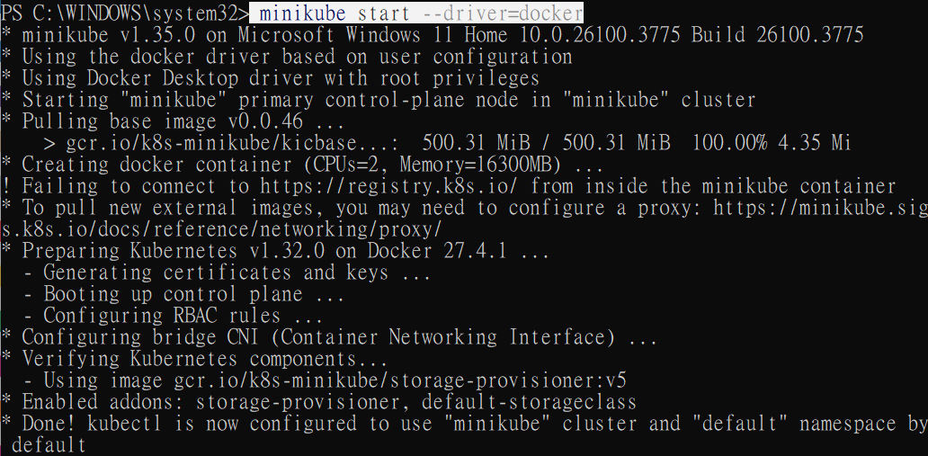

**Testing minikube**

minikube status

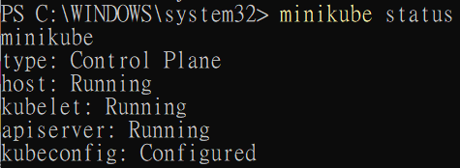

**Looking into our K8S Cluster**

minikube dashboard

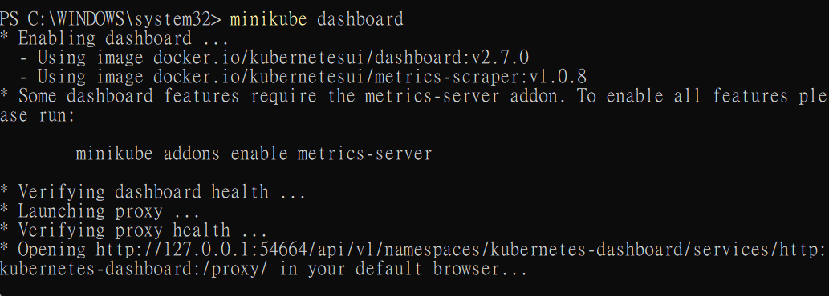

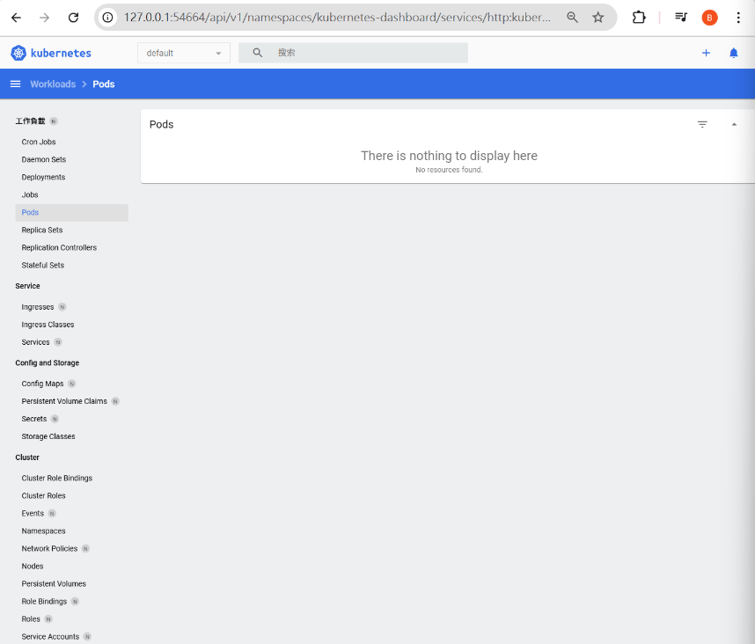

"Pod" Object

2025年4月19日

下午 05:49

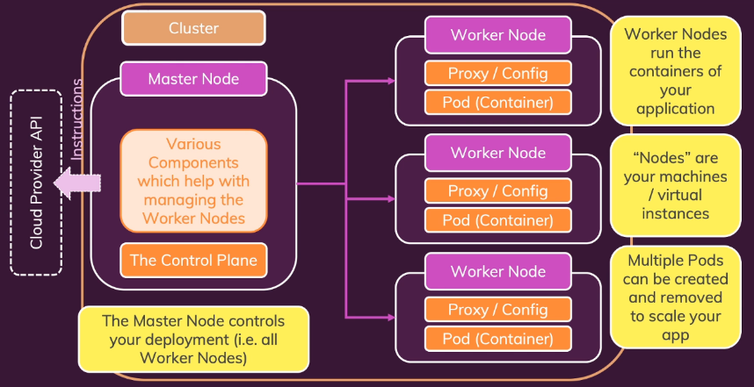

K8S works with **Objects**

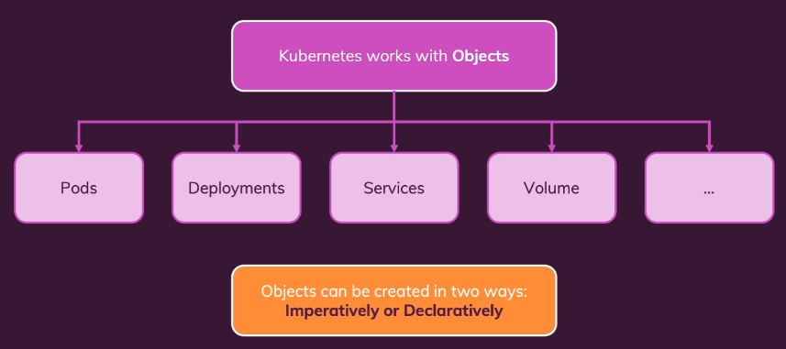

**"Pod" Object**

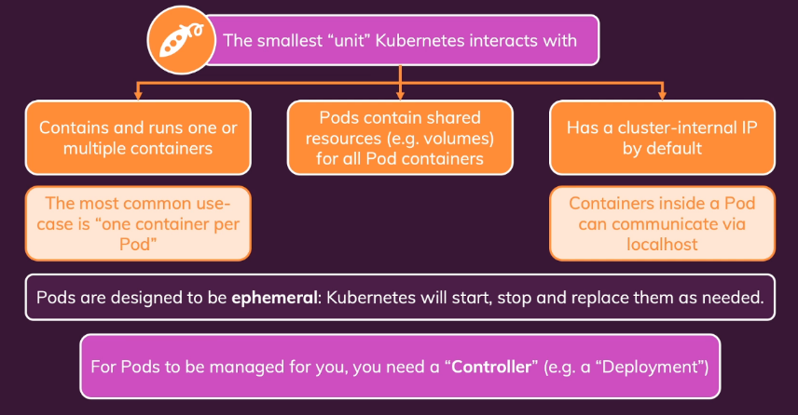

**Ephemeral**:

Pods will lose all data when they are destroyed

"Deployment" Object

2025年4月19日

下午 05:58

**\*\* Normally, we do not directly Control (multiple) Pods**

**Instead, we leverage "Deployment" Object to do so \*\***

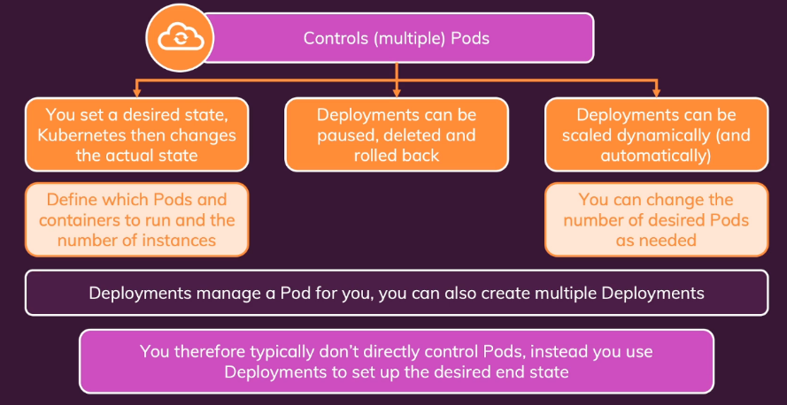

**Deployments**:

- Can be paused, deleted & rolled back

- Can allow auto-scaling

1st deployment (Imperative)

2025年4月19日

下午 06:04

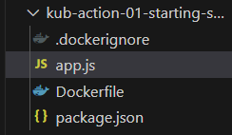

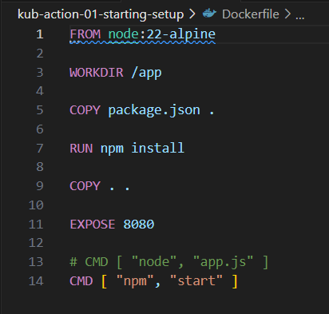

Build the Docker image

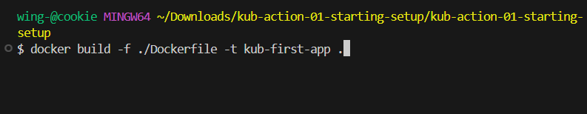

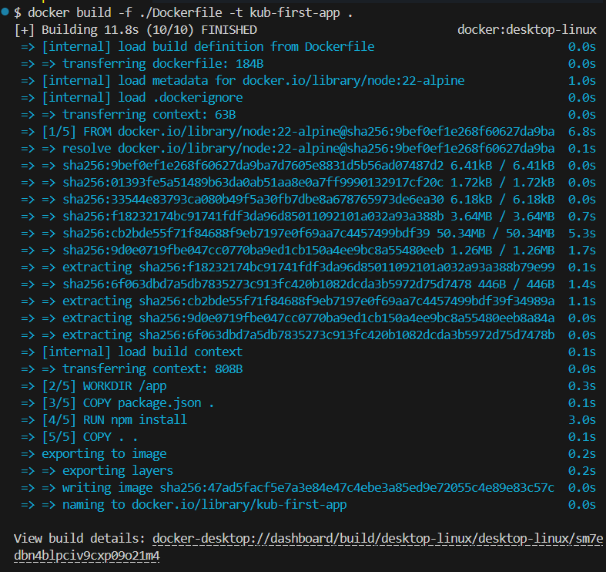

**Send the built docker image to K8S Cluster**

as part of a Deployment which will then create the Pods

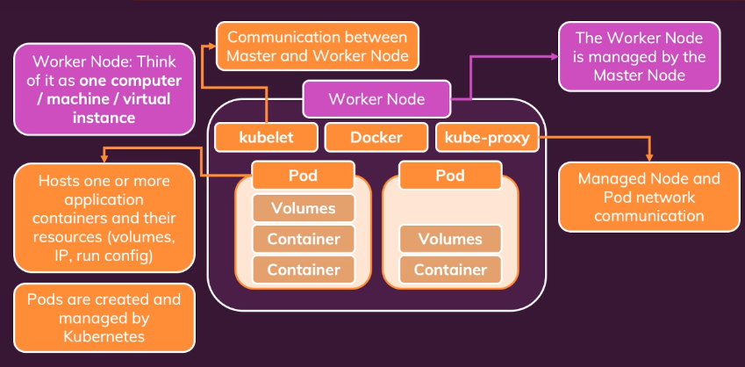

**To confirm our minikube cluster is up & running**

minikube status

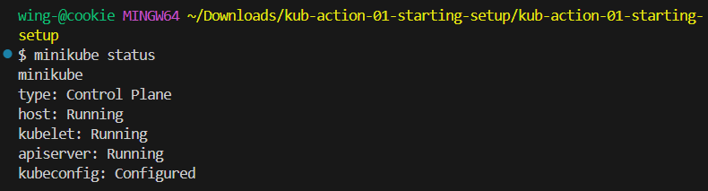

**No matter where our K8S Cluster resides (Local/Cloud),**

**we always use "kubectl" to send instructions to our Master Node (Control Plane)**

**Imperative way of creating "Deployment" Object**

kubectl create --help

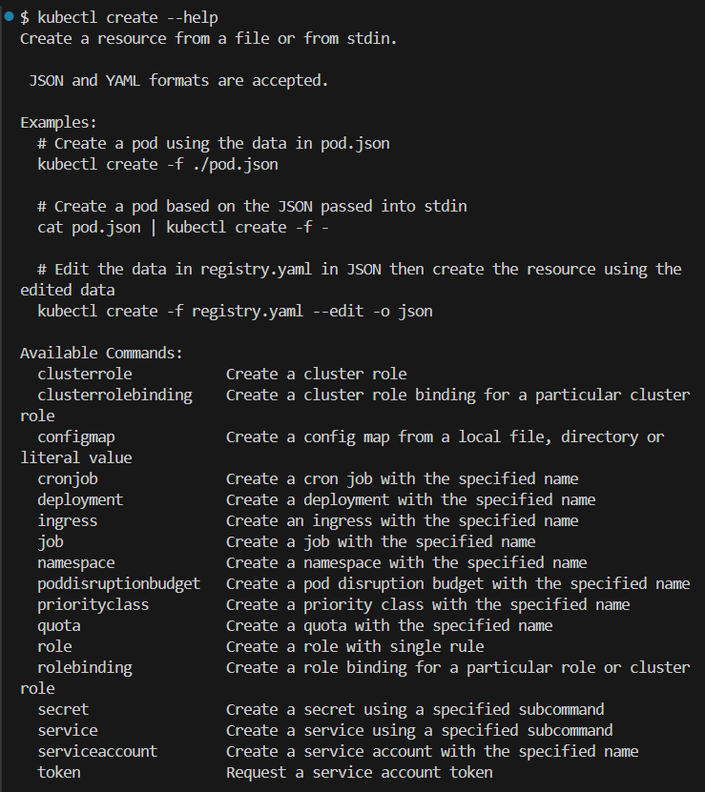

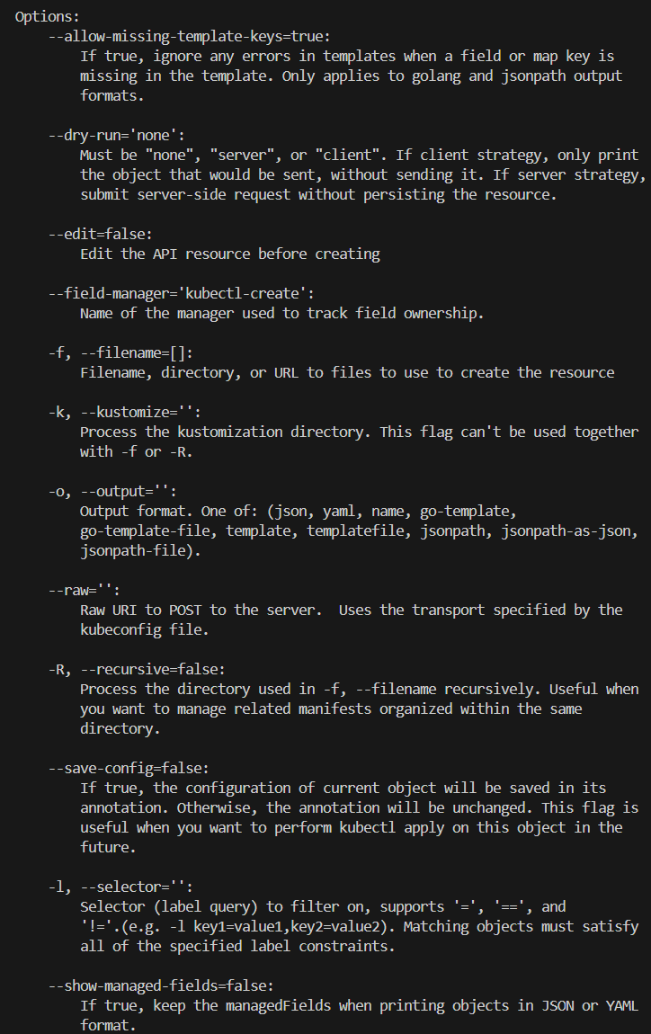

**Imperatively creating a "Deployment" Object using a Docker image**

kubectl create deployment <appName> --image=<dockerRegistryPath>

**Login to our Dockerhub**

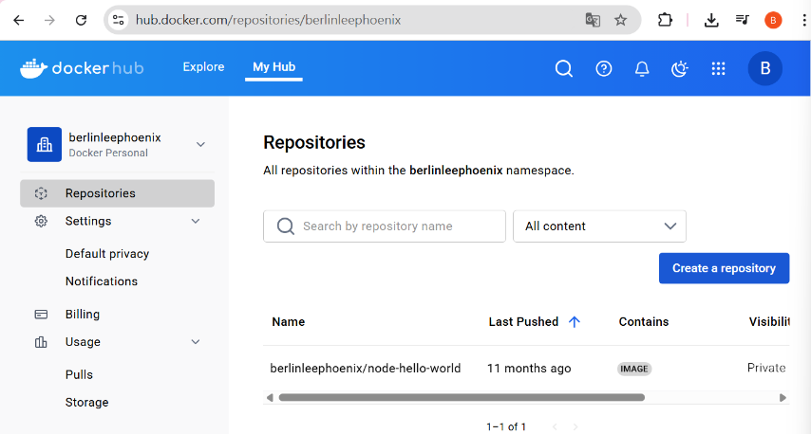

Create a repository

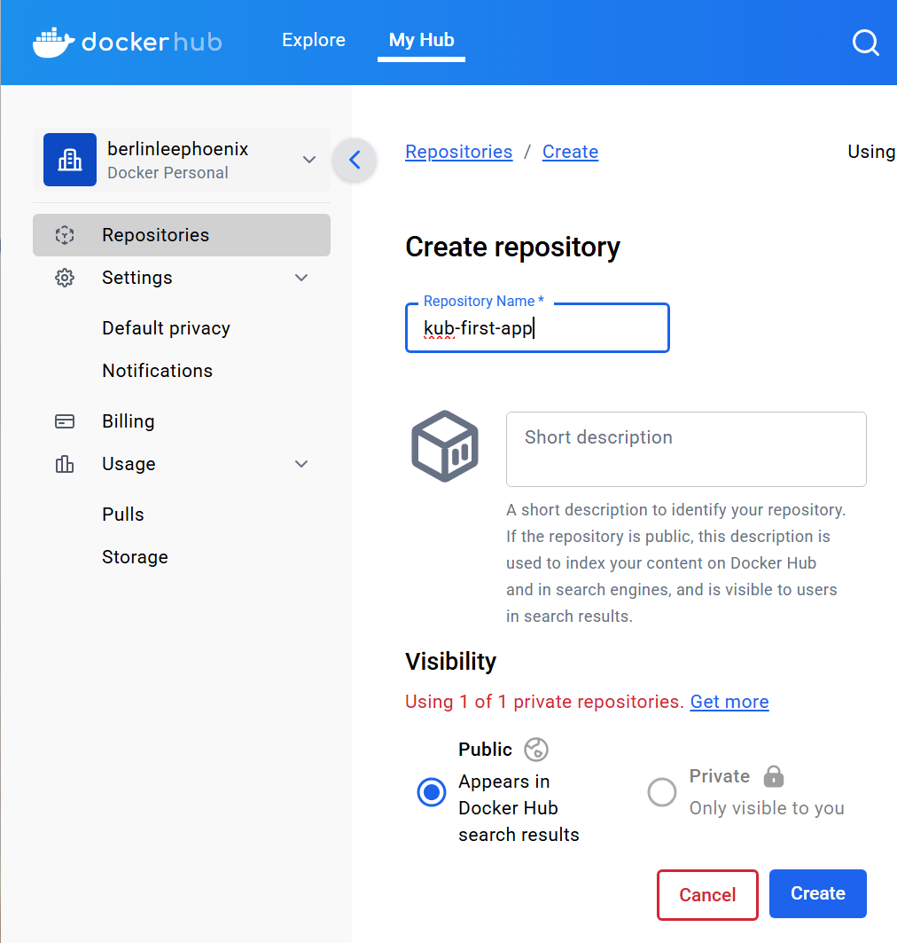

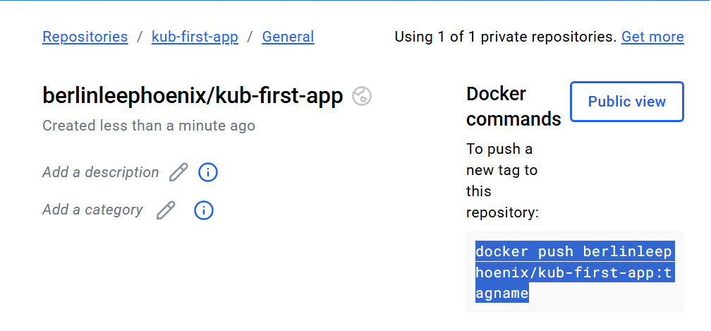

**Login to our Docker hub in vscode**

docker login -u berlinleephoenix

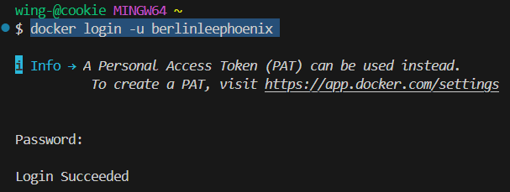

**To tag our Docker image before pushing:**

docker tag kub-first-app berlinleephoenix/kub-first-app:latest

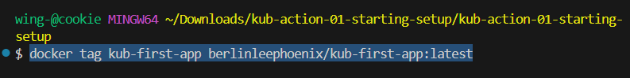

**To push a Docker image:**

docker push berlinleephoenix/kub-first-app:tagname

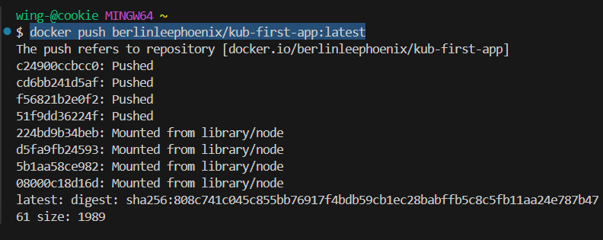

**Start our minikube K8S Cluster dev env locally again**

minikube start

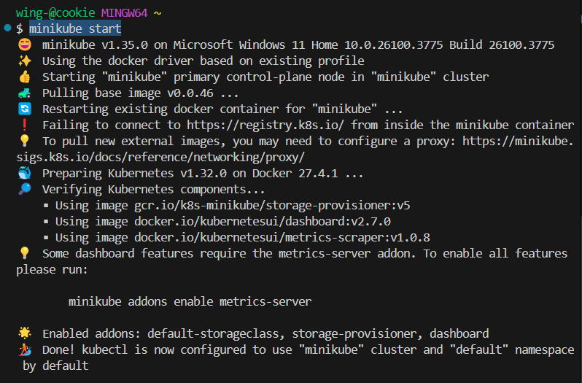

**Inspect our minikube K8S dashboard**

minikube dashboard

**kubectl to create a deployment using the Docker image pushed to our Docker Hub (Registry)**

kubectl create deployment kub-first-app --image=berlinleephoenix/kub-first-app

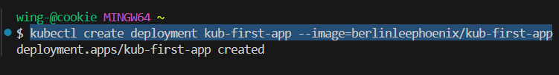

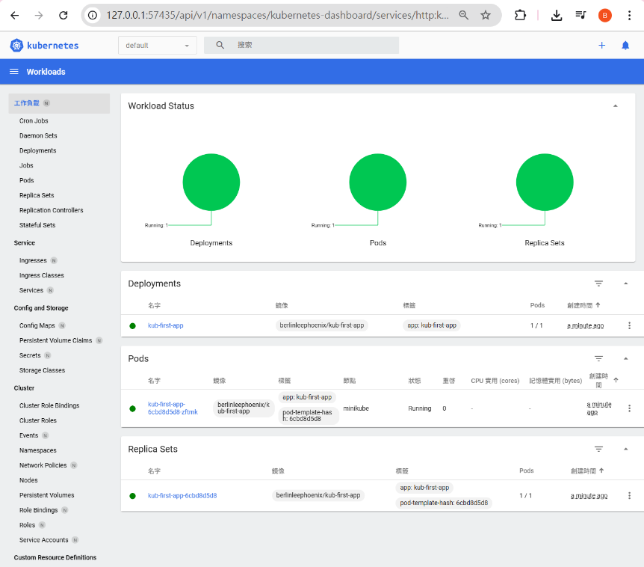

**To retrieve latest K8S deployments**

kubectl get deployments

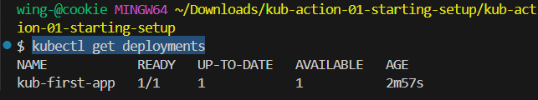

**To retrieve all K8S Pods (config + volume + containers)**

kubectl get pods

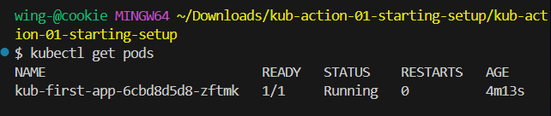

**kubectl Behind the Scenes**

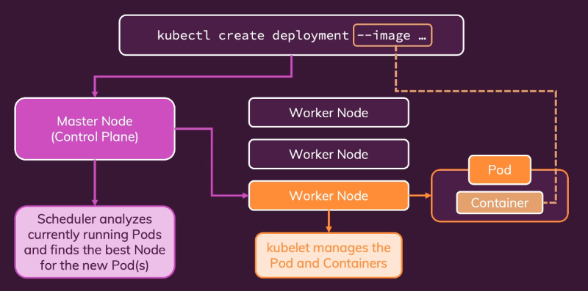

"Service" Object

2025年4月19日

下午 07:00

**Exposing Pods** to the Cluster or **Externally**

**Pods** have an **internal IP** by default

(**changes** when Pod is **replaced**)

** **Services group Pods with a shared IP**

**(does not change)**

**\*\* Services can allow external access to Pods outside local Cluster**

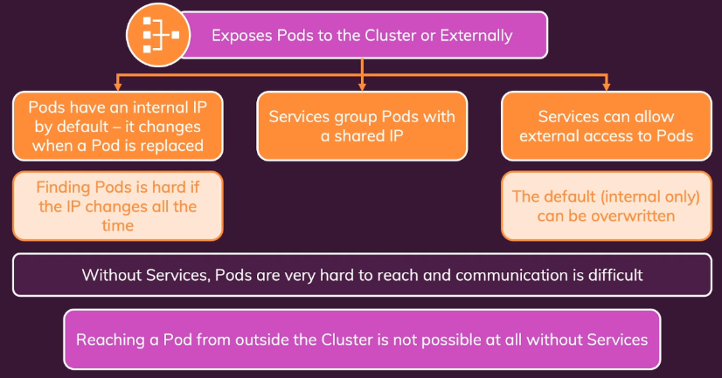

Exposing a Deployment with a Service

2025年4月19日

下午 10:29

**Get Deployments**

kubectl get deployments

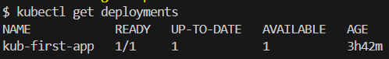

**Exposing a deployment --type=ClusterIP (from inside Cluster)**

kubectl expose deployment kub-first-app --type=ClusterIP --port=8080

**Exposing a deployment --type=LoadBalancer**

**(provide a unique IP & auto load balancing)**

kubectl expose deployment kub-first-app --type=LoadBalancer --port=8080

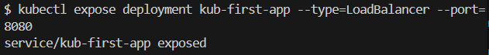

**\*\* A Load Balancer generates a unique address for the service**

**Retrieve K8S services**

kubectl get services

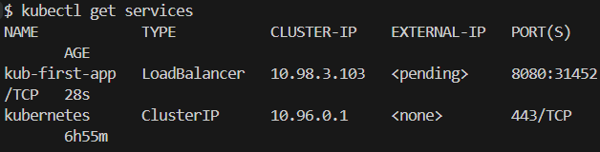

**Allowing minikube to map K8S service**

minikube service kub-first-app

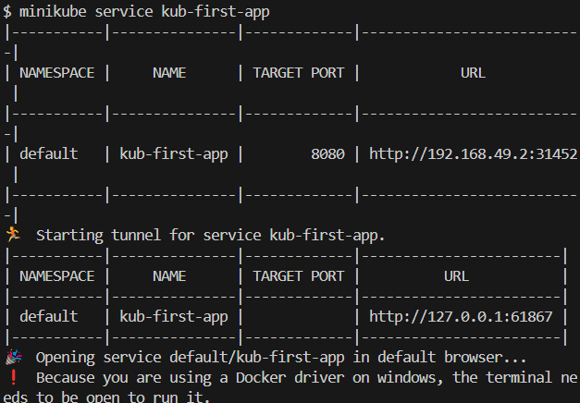

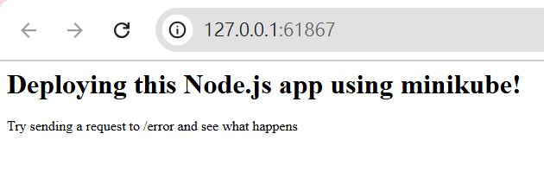

Restarting containers

2025年4月19日

下午 10:46

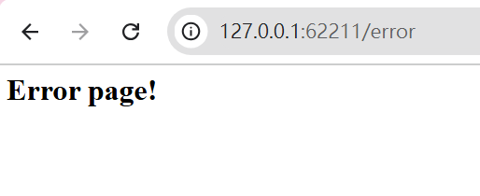

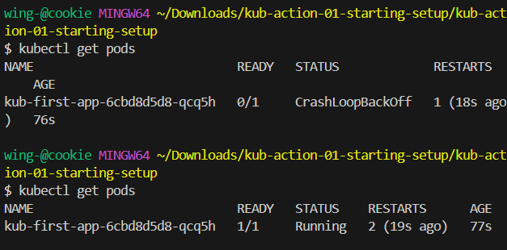

Scaling in Action

2025年4月19日

下午 10:52

**Scaling a deployment (Docker image) to 3 Pods**

kubectl scale deployment/kub-first-app --replicas=3

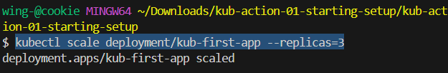

kubectl get pods

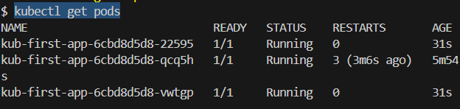

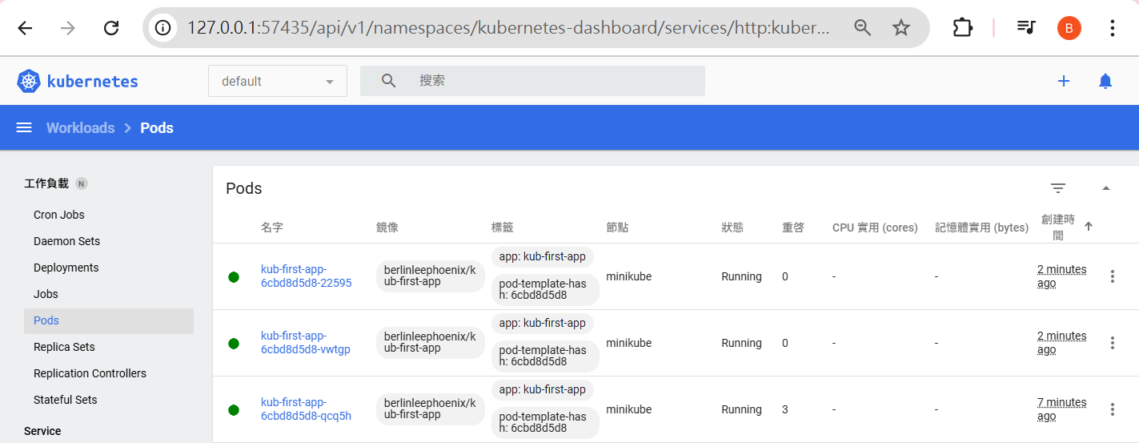

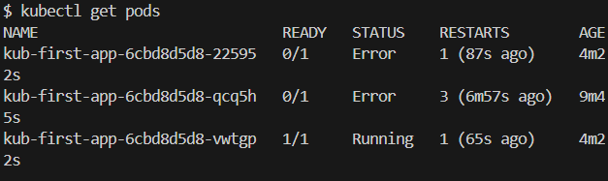

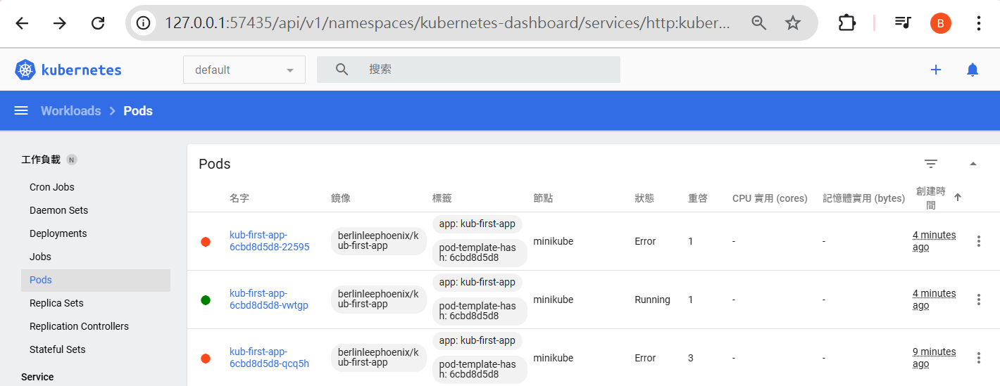

**Scale down our kub-first-app with replicas=1 again**

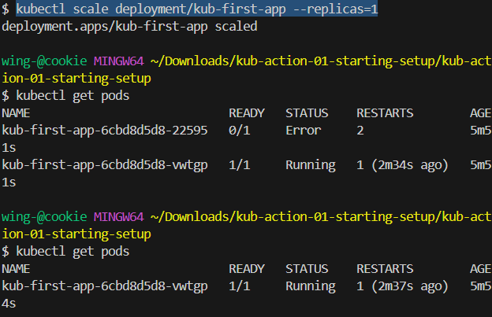

Updating deployments

2025年4月19日

下午 11:01

Chaning source code in app.js

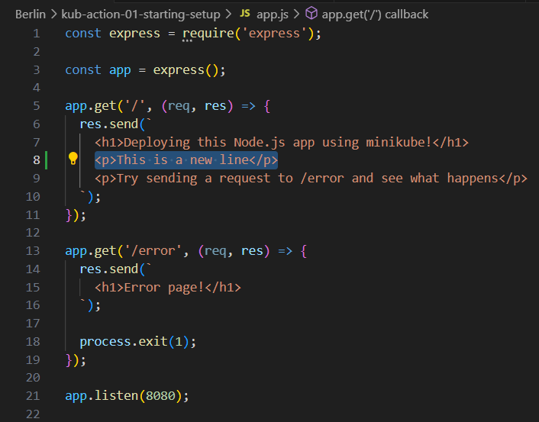

docker build -> docker tag -> docker push again

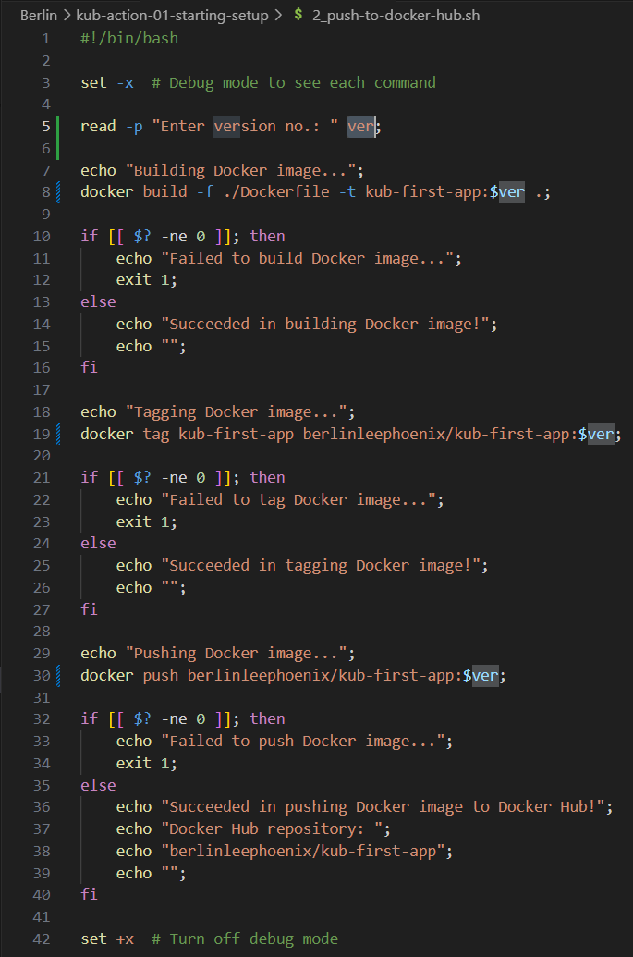

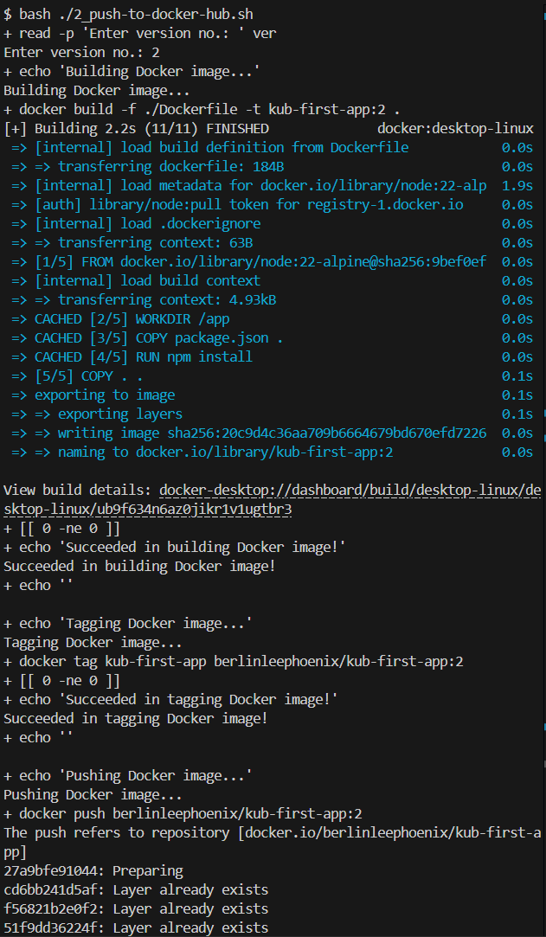

**Updating our docker image used by kubectl by referrencing to our Docker Hub**

kubectl set image deployment/kub-first-app kub-first-app=berlinleephoenix/kub-first-app:$ver

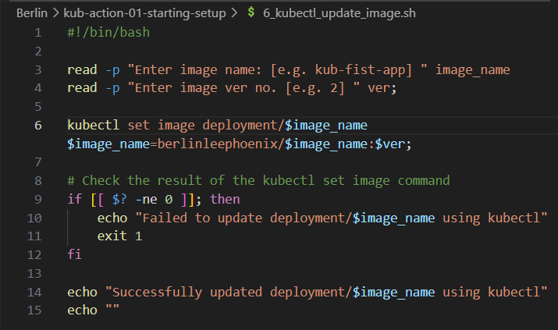

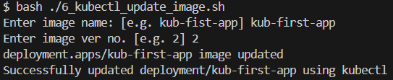

kubectl get deployments

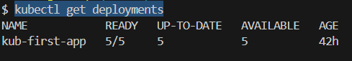

Code changes have been reflected

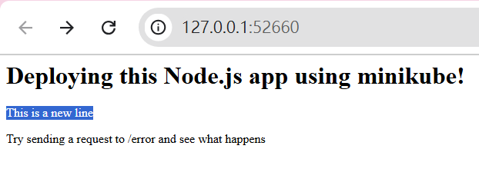

**Viewing updated status**

kubectl rollout status deployment/kub-first-app

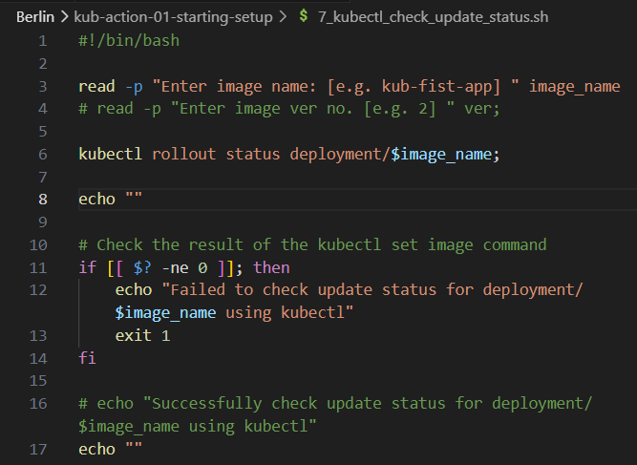

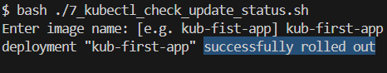

Checkout minikube dashboard -> Pods

image berlinleephoenix/kub-first-app:2 has rolled out

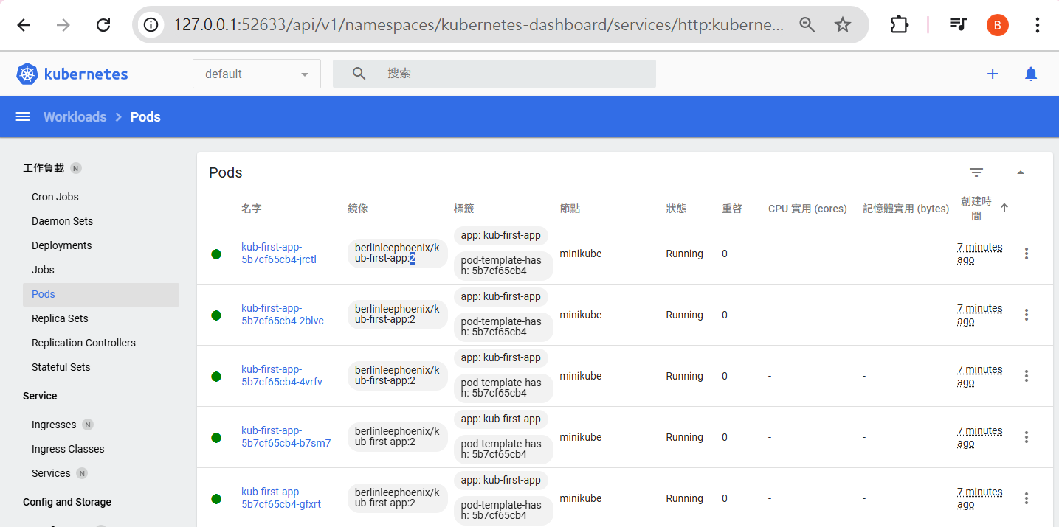

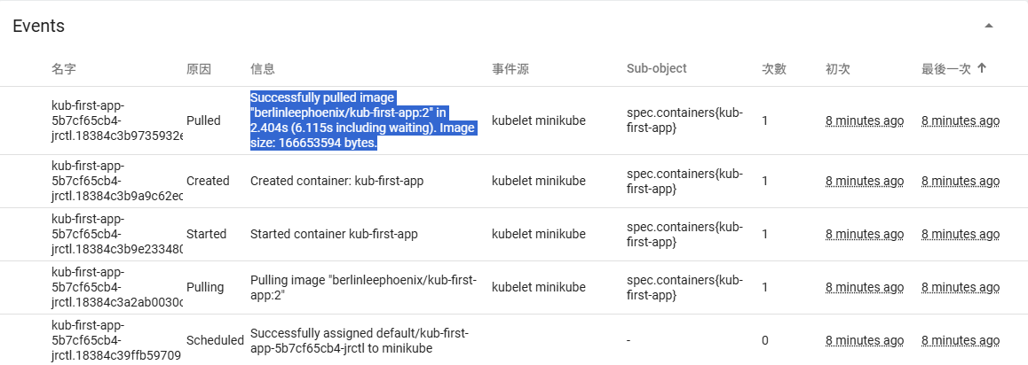

Rollback deployment & history

2025年4月21日

下午 05:58

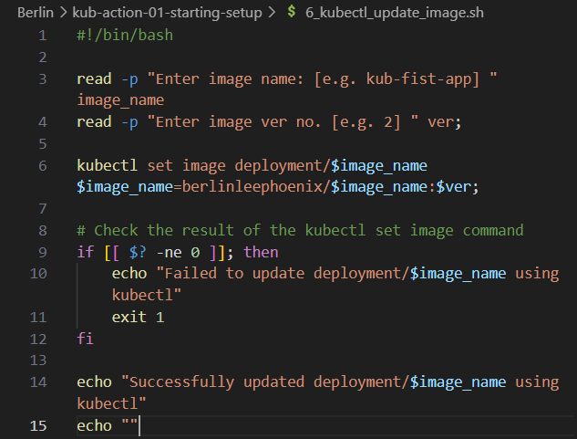

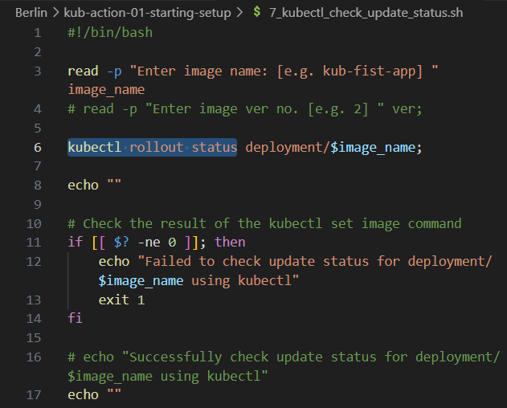

**Trying to kubectl set image to a non-existing tag**

kubectl set image deployment/kub-first-app kub-first-app=berlinleephoenix/kub-first-app:3

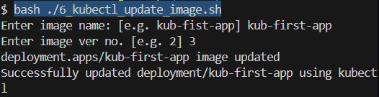

**Check rollout status of deployment/kub-first-app**

kubectl rollout status deployment/kub-first-app

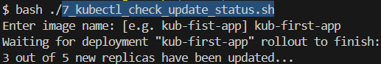

Now, in our minikube dashboard -> Pods:

Failed to pull image "berlinleephoenix/kub-first-app:3"

Thus, old Pods are not terminating

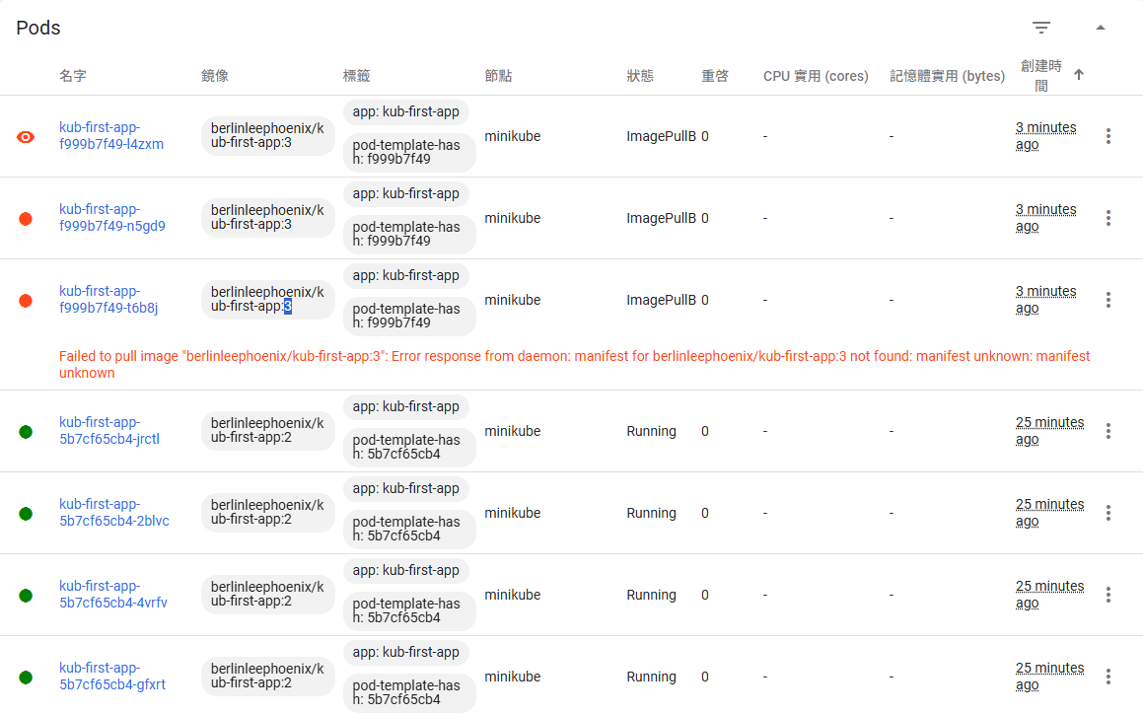

**Rolling back the latest failed deployment**

kubectl rollout undo deployment/kub-first-app

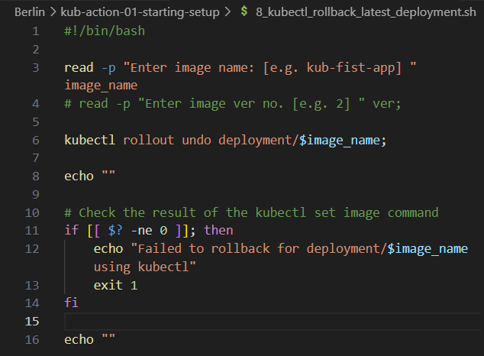

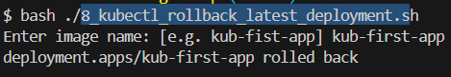

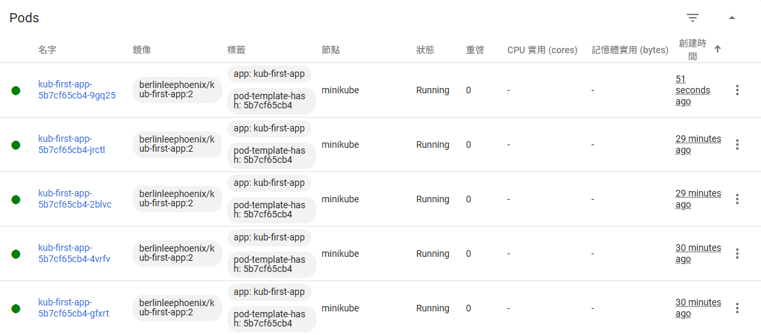

**Checking rollout history of an app**

kubectl rollout history deployment/kub-first-app

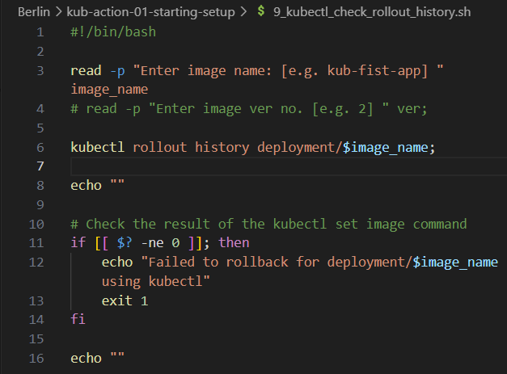

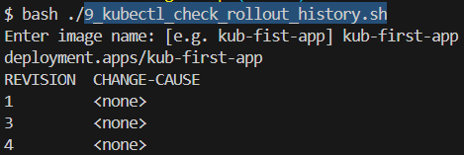

**Check detail rollout history for a specific revision of an app**

kubectl rollout history deployment/kub-first-app --revision=3

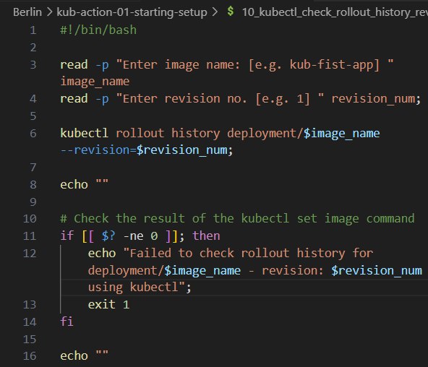

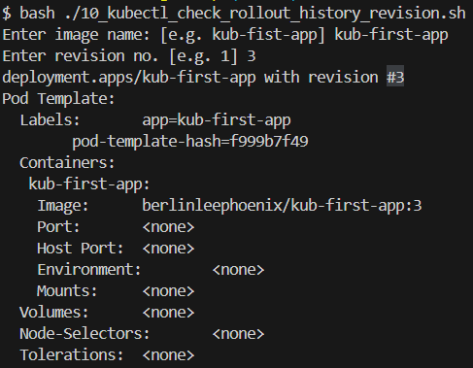

**Rolling back a deployment to a specific revision no.**

kubectl rollout undo deployment/kub-first-app --to-revision=1;

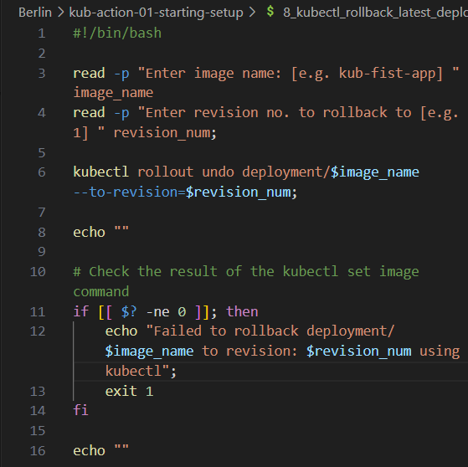

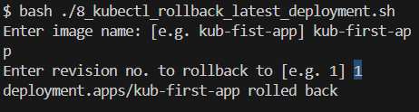

Imperative vs Declarative

2025年4月21日

下午 07:26

Resource Definition file:

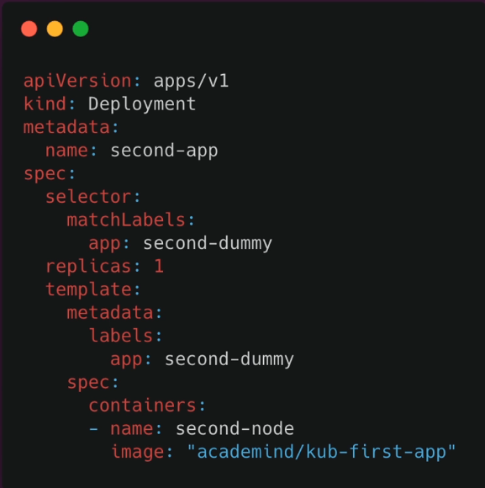

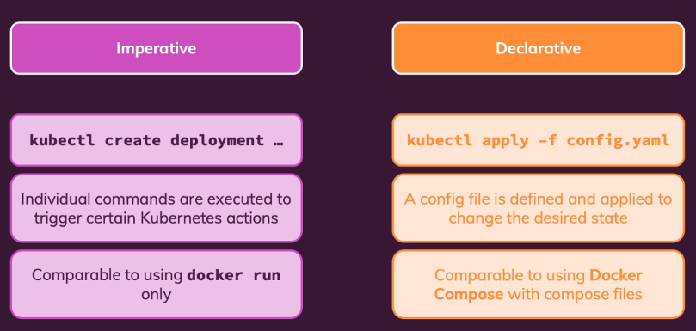

Deployment Configuration File

2025年4月27日

下午 05:06

<https://kubernetes.io/docs/concepts/workloads/controllers/deployment/>

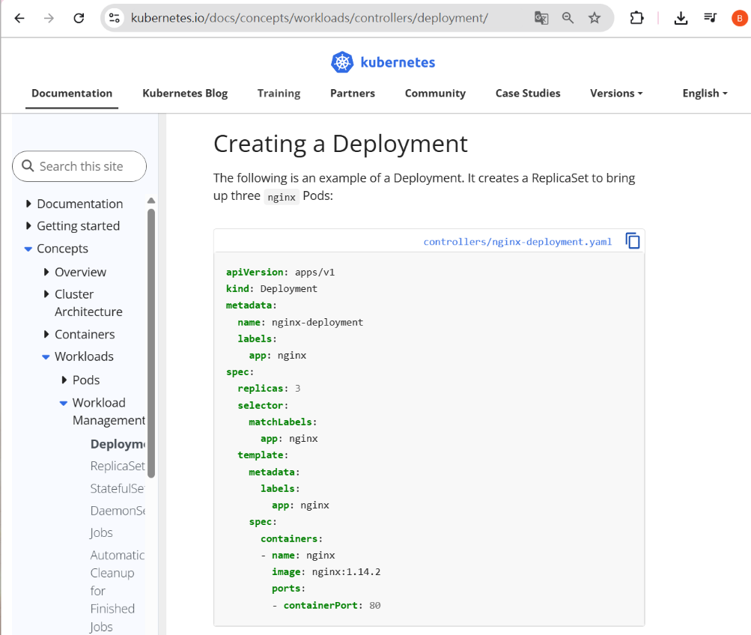

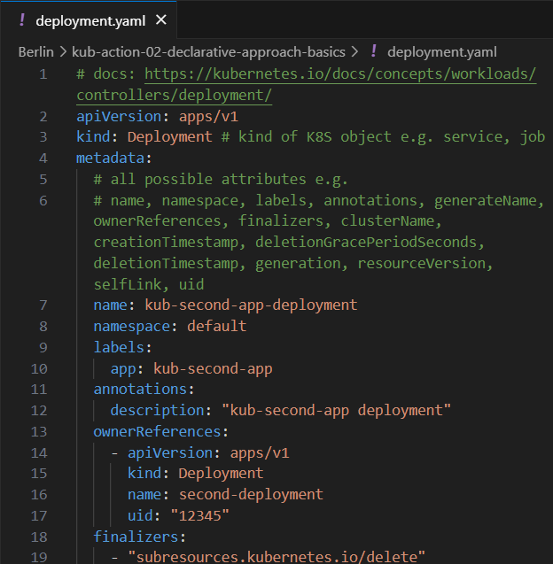

Adding Pod & Container specs

2025年4月27日

下午 05:38

<https://kubernetes.io/docs/reference/generated/kubernetes-api/v1.27/#podtemplatespec-v1-core>

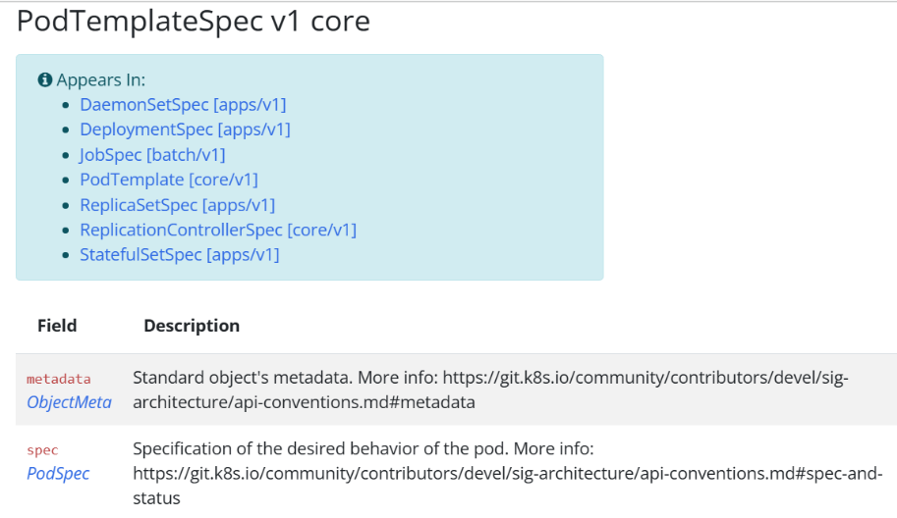

For template > metadata attributes

<https://kubernetes.io/docs/reference/generated/kubernetes-api/v1.27/#objectmeta-v1-meta>

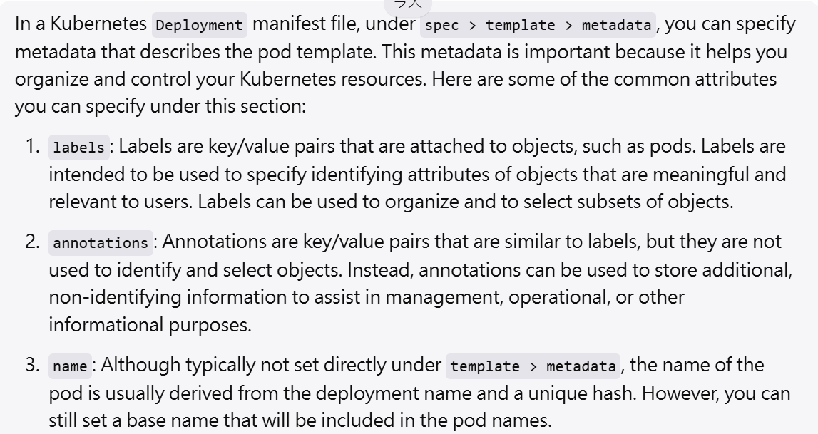

template:

metadata:

app:

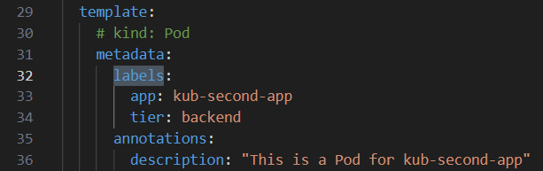

<https://kubernetes.io/docs/reference/generated/kubernetes-api/v1.27/#podspec-v1-core>

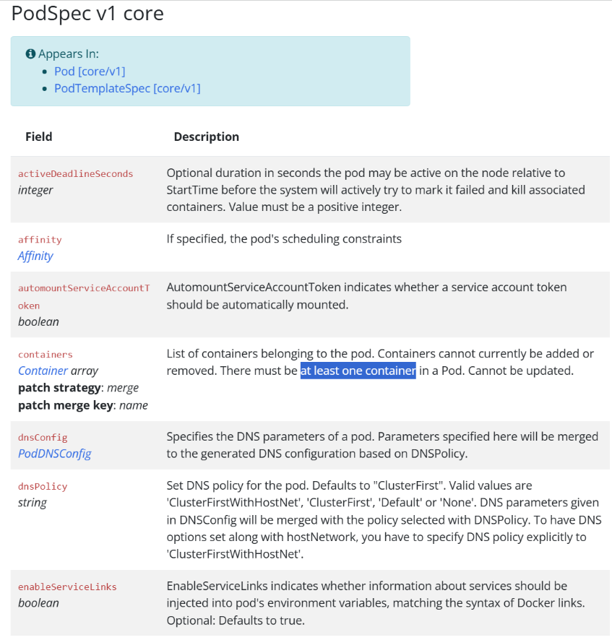

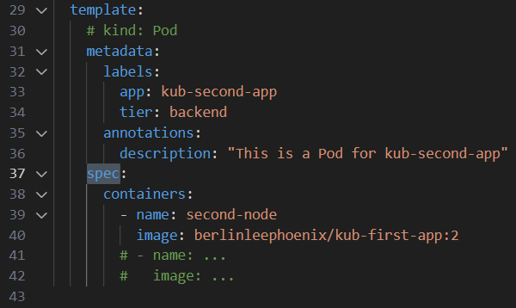

**To create a K8S deployment using kubectl**

kubectl apply -f=deployment.yaml

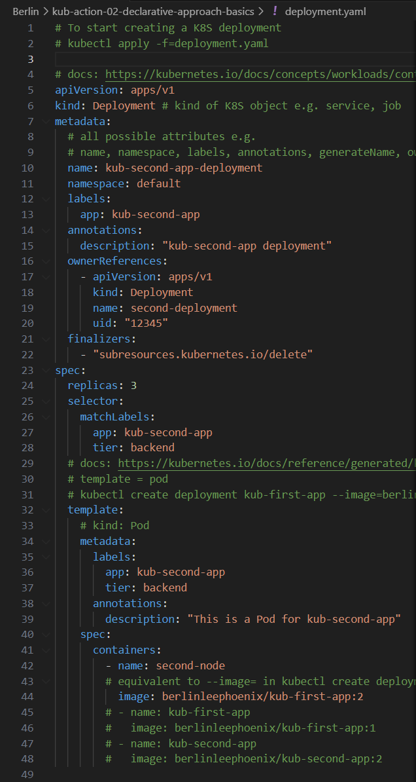

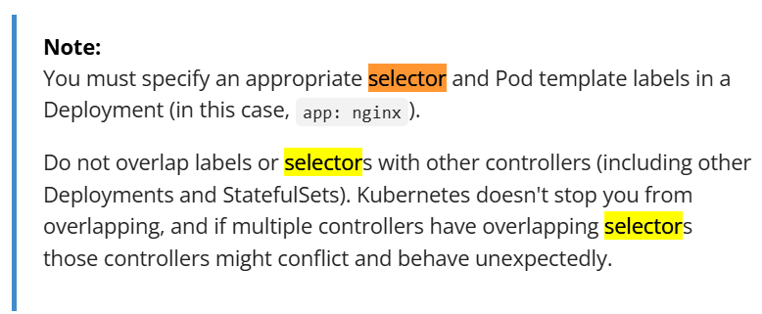

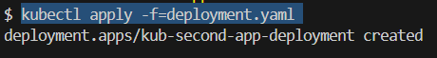

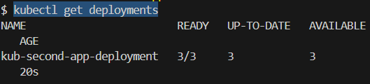

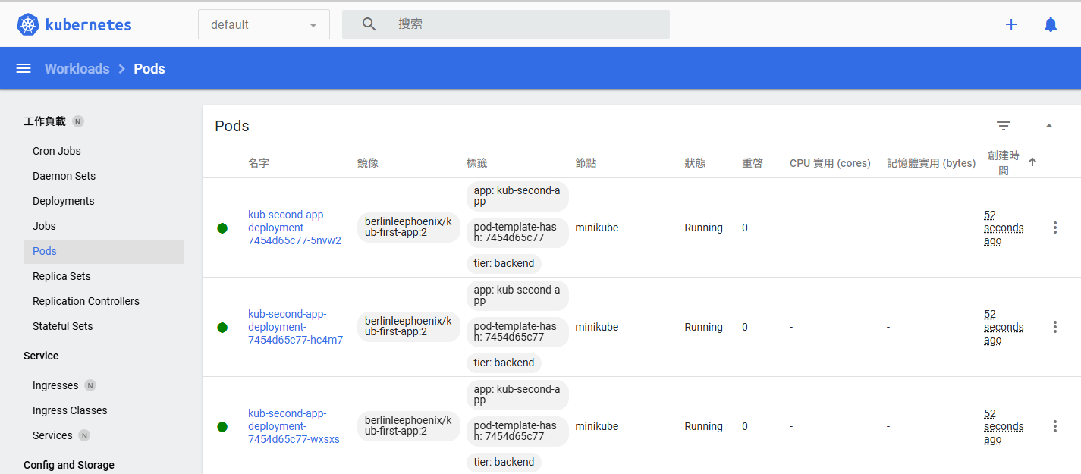

Working with Labels & Selectors

2025年4月27日

下午 06:07



